

University Name: Syrian Private University
Specialization: Software Engineering

VitaMate: A smart lifestyle and health tracking application.
A Junior Project submitted in partial fulfillment of the requirements of the Fifth Year, Faculty of Software Engineering, Syrian Private University.

Prepared by:
Salam Mohammed Al-Ayash
Amenah Ayman Zaitoun
Supervised by:
Eng. Raghad Al-Hossny

Academic Year: 2025 – 2026
Damascus, Syria

Chapter 1 Introduction

Introduction:
In this chapter, we provide a brief overview of our project, highlighting the main problem it aims to address. Additionally, we outline the key objectives and goals that this system seeks to achieve.

Overview of the Field and Project Significance:
In today’s fast-paced world and with the growing prevalence of unhealthy lifestyles, many individuals struggle to modify their habits and overcome behaviors that negatively impact their physical and mental well-being. This has created an increasing demand for an intelligent health assistant capable of tracking daily routines and supporting users in improving their overall lifestyle.
Based on this need, the VitaMate project was conceived. VitaMate is an intelligent health assistant application designed to monitor and enhance users’ well-being holistically by tracking nutrition, water intake, physical activity, sleep quality, medication adherence, and by assisting users in breaking unhealthy habits.

Problem Definition:
A large number of individuals struggle to maintain consistent healthy daily habits essential for their physical and mental well-being. These include eating a balanced diet, drinking sufficient amounts of water, engaging in regular physical activity, and maintaining proper sleep schedules.
Neglecting these habits often leads to a gradual decline in overall health and increases the risk of developing chronic conditions such as obesity, hypertension, diabetes, and sleep disorders. It can also negatively affect one’s psychological state and daily productivity.
Therefore, there is a growing need for an intelligent and comprehensive system that assists individuals in managing their health more effectively by tracking their daily behaviors, providing personalized reminders, and offering analytical insights to help them monitor progress and continuously improve their lifestyle.
The VitaMate application addresses this issue by offering a digital platform designed to help users establish sustainable healthy habits and enhance their self-awareness toward better health management.

Project Objectives:

General Objective:
The VitaMate project aims to develop an intelligent mobile application that helps users adopt a healthier lifestyle by monitoring nutrition, physical activity, sleep patterns, water intake, and eliminating unhealthy habits.

Specific Objectives:
- Track daily caloric intake and food quality based on the user’s health condition and personal goals.
- Monitor water consumption levels and encourage users to maintain proper daily hydration.
- Track users’ physical activity and monitor their exercise routines regularly.
- Assist users in overcoming unhealthy habits such as smoking or excessive sugar consumption.
- Regulate sleep schedules and improve sleep quality to achieve a balanced and healthy rest pattern.
- Provide weekly and monthly health reports that include analytics and personalized recommendations for lifestyle improvement.

Project Scope:

In-Scope:
- Development of a comprehensive mobile application designed to monitor and promote a healthy lifestyle.
- A secure login system ensuring user data protection and privacy.
- A PostgreSQL database for storing and managing user information and health-related habits.
- A notification system to remind users of their daily goals and scheduled activities.
- User-friendly and interactive interfaces that provide clear health metrics and progress indicators, supported by a motivational point-based system.

Project Significance:

Practical Benefits:
- Assisting users in adopting a balanced and healthy lifestyle through consistent behavior tracking.
- Regularly monitoring nutrition, physical activity, and sleep to enhance overall well-being.
- Promoting health awareness and encouraging users to make positive changes in their daily habits.
- Supporting users in maintaining commitment to healthy routines and achieving their personal goals.

Scientific Benefits:
- Implementing modern technologies such as Flutter and Django in the development of intelligent health applications.
- Gaining practical experience in designing and building an integrated health monitoring system.
- Utilizing user-generated data to analyze health patterns and enabling future integration of artificial intelligence to improve recommendation accuracy.

Chapter 2

Basic concepts and literature review

Introduction:
This chapter provides a comprehensive overview of the fundamental concepts underlying the Vitamate project — an intelligent system designed to monitor and improve users’ lifestyles.
It covers the theoretical foundations related to healthy habit tracking, health data management, self-motivation, and behavioral analysis.
Understanding these concepts is essential to demonstrate how the system supports users in enhancing their health and making informed decisions that improve their overall well-being.

Fundamental Concepts:

▪ Healthy Lifestyle Tracking
Healthy lifestyle tracking refers to the process of monitoring daily behaviors that influence an individual’s health, such as nutrition, physical activity, sleep, and water intake.
This tracking helps identify positive and negative habits and analyze their impact on overall well-being.
Lifestyle tracking systems are effective tools for increasing self-awareness and supporting users in setting measurable goals and monitoring their progress.

▪ Health Balance and Prevention
The concept of balanced health emphasizes maintaining harmony between various factors such as proper nutrition, regular exercise, and sufficient rest.
This balance plays a key role in preventing chronic diseases such as obesity, diabetes, and cardiovascular conditions.
The Vitamate project aims to support this balance by monitoring daily health indicators and alerting users when adjustments in behavior are needed.

▪ Self-Motivation and Behavioral Change
Self-motivation is a crucial factor in maintaining healthy habits over time.
Studies have shown that continuous feedback and symbolic rewards can significantly enhance adherence and encourage long-term improvement.
Vitamate applies a points-based reward system to motivate users to achieve their daily goals and foster a sense of accomplishment.

▪ Smart Reminders and Daily Follow-Up
Health reminder systems help users organize their time and maintain consistency in their daily habits.
Reminders are effective tools for reducing forgetfulness and improving adherence to healthy routines, such as drinking water regularly, exercising, or maintaining proper sleep patterns.
In Vitamate, reminders serve as a core feature to ensure daily engagement and sustained progress toward personal health goals.

▪ Health Behavior Analysis
Health behavior analysis involves interpreting recorded user data to assess progress and lifestyle trends.
Through this analysis, the system identifies strengths and weaknesses in user habits and suggests targeted improvements.
Behavioral analysis tools enable users to visualize the impact of their habits on overall health, encouraging consistent and informed self-improvement.

▪ Health Awareness
Health awareness refers to an individual’s understanding of how lifestyle choices affect physical and mental well-being.
Promoting health awareness is one of the primary objectives of modern health systems, as it empowers users to make knowledge-based decisions instead of random or reactive ones.
Vitamate enhances health awareness by presenting users with clear, understandable insights about their daily performance and long-term progress.

▪ Health Data Management
Health data management involves collecting, organizing, and analyzing user-related information to create a comprehensive overview of health status.
This process must be accurate, reliable, and privacy-conscious.
Data management forms the foundation of any intelligent health system, enabling accurate reporting and data-driven recommendations for users.

▪ Reports and Feedback
Periodic reports allow users to evaluate their progress toward their health goals.
Feedback plays a key role in improving performance and modifying behavior by providing clear indicators of both progress and areas needing attention.
Vitamate offers weekly and monthly reports summarizing users’ health performance, encouraging continuous lifestyle improvement.

▪ Privacy and Health Data Security
Privacy is a critical concern in digital health systems due to the sensitivity of personal user information.
Such systems must guarantee secure data handling and prevent unauthorized access.
Vitamate emphasizes the importance of data protection by securely storing user information and maintaining confidentiality according to modern technical standards.

▪ The Future of Smart Health Systems
Modern digital health solutions are increasingly integrating intelligent analysis and personalized recommendations.
With advancements in artificial intelligence, future systems can predict user behavior and provide more precise, adaptive health guidance.
The Vitamate project represents an early step toward this direction by collecting and analyzing data to support evidence-based health decisions.

3. Reference Study

Selected Reference Applications:
A set of the most widely used and recognized global health and lifestyle applications were selected based on their popularity, functionality, and effectiveness in promoting healthy habits. The selected applications include:
- MyFitnessPal
- Google Fit
- WaterMinder
- Sleep Cycle
- Habitica

Analysis of Similar Applications:

MyFitnessPal:
Main Purpose:
Tracking users’ calorie intake and dietary habits.
Core Features:
a. Logging daily meals and food items.
b. Calculating calories per meal in relation to the daily goal.
c. Providing detailed reports and graphical insights about nutritional progress.
Key Advantages:
a. A user-friendly interface with access to a vast food database.
b. Integration with fitness tracking devices for activity synchronization.


Google Fit:
Main Purpose:
Comprehensive monitoring of users’ physical activity and overall health through motion, step count, calorie tracking, and sleep analysis using mobile sensors or wearable devices.
Core Features:
a. Step counting.
b. Calorie estimation.
c. Distance measurement.
d. Daily activity level tracking.
e. Sleep and heart rate monitoring (when connected to smart devices).
f. Providing daily and weekly health indicators such as Heart Points.
g. Data synchronization with other applications (e.g., MyFitnessPal, Sleep as Android).
Key Advantages:
a. Strong integration with Android Wear and other smart devices.
b. Well-structured dashboards that visualize health progress.
c. Ability to customize daily health goals based on user preferences.


WaterMinder:
Main Purpose:
Encouraging users to maintain adequate hydration throughout the day.
Core Features:
a. Determining daily water intake goals based on user weight and activity level.
b. Sending periodic reminders to drink water.
c. Displaying hydration levels in graphical form.
Key Advantages:
a. Smart reminders based on real-time user activity.
b. Customizable notifications according to user preferences.

Sleep Cycle:

Main Purpose:
Monitoring and analyzing users’ sleep quality and patterns.
Core Features:
a. Recording sleep duration and restfulness.
b. Using sensors to analyze body movements during sleep.
c. Offering recommendations to improve sleep quality and determine optimal wake-up times.
Key Advantages:
a. Detailed reports on sleep quality and ideal wake-up moments.
b. Simple interface allowing users to monitor sleep trends over time.

Habitica:

Main Purpose:
Motivating users to maintain healthy and productive habits through a gamified experience.
Core Features:
a. Creating daily habit lists and health-related tasks.
b. Transforming task completion into XP points and virtual rewards.
c. Allowing users to share progress and achievements with friends or teams for added motivation.
Key Advantages:
a. Incorporating Gamification principles to make habit tracking engaging and enjoyable.
b. Visually appealing interface that encourages consistent participation.

Summary:
Feature / Application | Habitica | Sleep Cycle | WaterMinder | Google Fit | MyFitnessPal | VitaMate
Nutrition Tracking | ✘ | ✘ | ✘ | ✘ | ✔ | ✔
Water Consumption Tracking | ✘ | ✘ | ✔ | ✘ | ✘ | ✔
Physical Activity Tracking | ✘ | ✘ | ✘ | ✔ | ✔ | ✔
Sleep Monitoring | ✘ | ✔ | ✘ | ✘ | ✘ | ✔
Progress Reports | ✘ | ✘ | ✘ | ✘ | ✘ | ✔
Motivational Reward System (Points) | ✔ | ✔ | ✔ | ✔ | ✘ | ✔
Lifestyle Score Calculation | ✔ | ✘ | ✘ | ✘ | ✘ | ✔
Interactive and User-Friendly Interface | ✘ | ✘ | ✘ | ✘ | ✘ | ✔
Habits System | ✔ | ✔ | ✔ | ✔ | ✔ | ✔
Synchronization With External Systems | ✘ | ✘ | ✘ | ✔ | ✔ | ✘
Custom Goal Creation | ✔ | ✔ | ✘ | ✘ | ✔ | ✔

Chapter 3

Project planning

Introduction:
Chapter three focuses on the comprehensive planning process required to manage and execute the project effectively. It includes the Project Charter, which defines the vision, objectives, and project scope, followed by the Statement of Work (SOW) that outlines the detailed tasks and deliverables. The chapter also introduces the Gantt Chart, representing the project timeline and task scheduling.
Additionally, the chapter discusses the development methodology, the tools and technologies used, and the risk management plan responsible for identifying potential challenges and proposing strategies to mitigate them. This structured planning framework ensures a clear roadmap for successful and efficient project implementation

2. Project charter:
A project charter is a formal document that serves as an official authorization for the start of a project. It acts as a reference point throughout the project, providing a clear understanding of the project's purpose and establishing a foundation for decision-making and project governance.

Item | Details
Project Title | A Health Assistant System That Helps Users Follow a Healthy Lifestyle
Project Start Date | 20-10-2025
Project End Date | 01-01-2026
Project Supervisor | Eng. Raghad Al-Hosani
Project Objectives | To develop an intelligent health assistant application that supports users in adopting and maintaining a healthy lifestyle by tracking nutrition, water intake, physical activity, and sleep habits. The system will include a motivational reward-based points mechanism to encourage consistency and long-term engagement.
Methodology / Approach | - Define the project scope and main objectives.  - Gather and analyze user requirements.  - Create and prioritize the Product Backlog.  - Conduct Sprint Planning to select tasks for each development cycle.  - Design the system architecture and database structure.  - Develop core functionalities through iterative Sprints using Scrum.  - Perform continuous testing to ensure quality and fix issues.  - Conduct Sprint Review to demonstrate progress and receive feedback.  - Run Sprint Retrospective to evaluate performance and improve processes.  - Document all development phases and prepare final delivery outputs.
Roles and responsibilities: | Name Role Responsibilities  Eng. Raghad Al-Hosani Project Supervisor Supervising project progress, guiding the team, reviewing project phases and deliverables  Amenah Zeitoun Engineer Requirements analysis, documentation, system design, technical coordination Developing frontend and backend components, database integration, and implementing system functionalities  Salam Al-Ayash Engineer

The SOW document:
Statement of Work is a comprehensive document that defines the scope of work for the Vitamate project. It outlines tasks, deliverables, responsibilities, and timeline. The document provides a clear understanding of the project objectives and success criteria.

Project Title | Vitamate – Smart Health & Wellness Assistant
Project Description & Objectives | Vitamate is a smart health tracking application that helps users improve their health habits by tracking water intake, sleep hours, calorie consumption, and physical activity. It provides reminders, reports, and insights through a friendly mobile interface. The system integrates with fitness sensors (Google Fit / Apple Health) to provide accurate real-time data and personalized recommendations.
Project Scope | The project includes developing a mobile application that enables users to monitor health habits such as water intake, sleep, calories, and workouts. It provides notifications, weekly/monthly reports, dashboards, and sensor integration. The system includes backend API, mobile frontend, user authentication, and deployment.
Project Goals | - Improve user lifestyle through habit tracking and data insights.  - Provide accurate real-time statistics using wearable sensors.  - Offer personalized recommendations and reminders.  - Deliver weekly/monthly dashboards and progress analytics.
Project Deliverables | - Vitamate mobile application (Android/iOS).  - Admin dashboard.  - Reports & analytics dashboards.  - User authentication & profile management.  - Physical activity tracking & sensor integration.  - Documentation package & final presentation.
Technology & Tools | - Frontend: Flutter  - Backend: Django REST Framework  - Database: PostgreSQL  - APIs: Google Fit / Apple Health  - Authentication: JWT  - Version Control: Git / GitHub
Assumptions | - Continuous availability of the development team.  - Availability of required development environment.  - Access to Google Fit & Apple Health APIs.  - Regular meetings with project manager for supervision and feedback.
Project Resources | Human Resources:  Raghad al Hossny- project management  Salam Al Ayash- SE Developer  Amenah Zaitoun- SE Developer
Schedules | - Project Start Date: 20.10.2025  - Sprint 0: 27.10.2025  - Sprint 1: 15.11.2025  - Sprint 2: 22.11.2025  - Sprint 3: 29.11.2025  - Sprint 4: 6.12.2025  - Sprint 5: 13.12.2025  - Project Finish Date: 20.12.2025
Milestones & Seminars | - First Seminar: 18.11.2025  - Second Seminar: TBA  - Final Presentation: Upon project delivery

Project plan – Gantt chart:
A document outlining tasks, deadlines, and resources needed to achieve project objectives, serving as a roadmap for successful project execution.
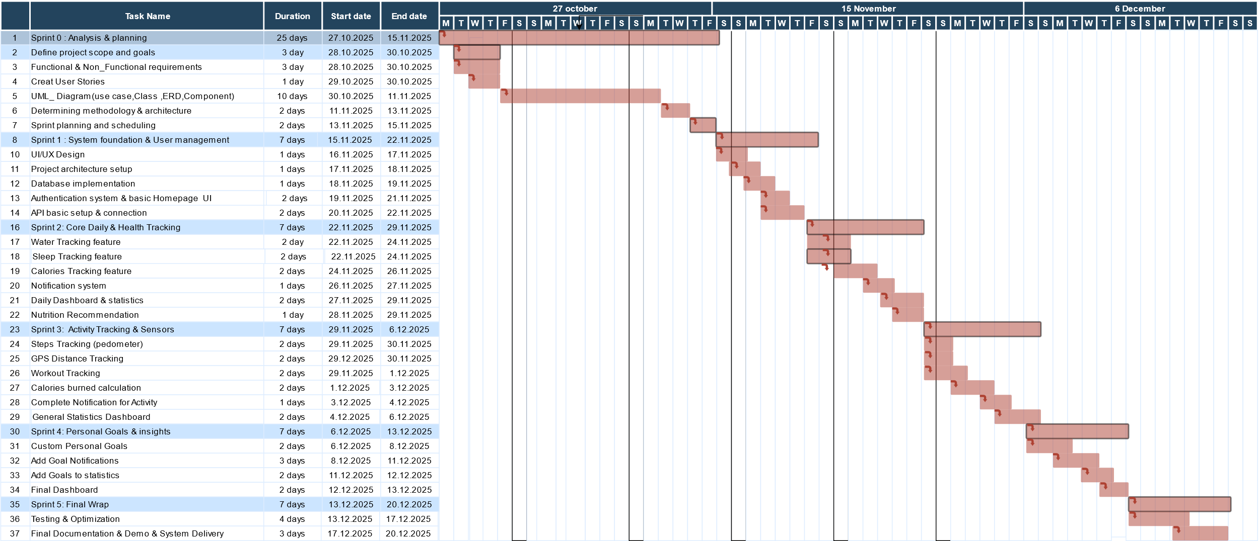

Risk Management:
the process of identifying, evaluating, and mitigating potential risks that could impact the success of a project or a team.

Risk_ID | RK-01 | RK-02 | RK-03 | RK-04
Risk Title | Small team size (only 2 members) | Large and expanding project scope | Learning and using new technologies | Dependency separation between backend & frontend
Risk Description | If one team member stops or gets delayed for any reason, project progress will be highly affected | Misunderstanding of scope or unclear requirements may lead to development mistakes | The project requires new technologies such as sensors integration and advanced data analytics which the team has limited experience with | Work is fully separated (backend vs frontend), causing integration issues and delays if coordination fails
Raised Date | 20/10/2024 | 25/10/2024 | 10/11/2024 | 16/11/2024
Tracking Frequency | Weekly | Daily | Weekly | Daily
State | Active | Under mitigation | Under mitigation | Active
Impact | High | Medium | High | Medium
Mitigation Plan | If one member finishes early, they support the other to keep the project moving | Weekly meetings to confirm requirements and scope clarification | Continuous learning, tutorials, and dividing the learning between members | Set integration checkpoints every sprint & assign a technical lead for alignment

6. Summary
- Effective project management is essential for the successful development of the Vitamate system.
- It ensures organized work, clear structure, and timely completion within scope and deadlines.
- By applying Agile Scrum, the team can identify risks early and improve the quality of the final product.
- Overall, strong project management supports delivering a high-quality system that meets user needs.

Chapter 4

System analysis

Software Requirements Specification (SRS):

Introduction
This document specifies the Software Requirements Specification (SRS) for the VitaMate system.
The purpose of this document is to provide a precise and complete description of the system’s functional and non-functional requirements. These requirements define the expected behavior, constraints, and quality attributes of the system to ensure correct implementation, verification, and future scalability.
This SRS serves as a contractual reference between stakeholders, developers, and evaluators, ensuring a consistent and unambiguous understanding of system requirements.

1.2. Overall Description

1.2.1. Product Perspective
VitaMate is a standalone mobile health and lifestyle tracking system supported by a backend server and a centralized database.
The system is designed using a client–server architectural model, where responsibilities are clearly separated to improve maintainability, scalability, and security.
The major architectural components are defined as follows:
The mobile application, implemented using Flutter, acts as the client interface through which users interact with the system.
The backend server, implemented using Django REST Framework, is responsible for executing business logic and providing RESTful APIs.
A PostgreSQL database is used to store persistent system and user data.
External health service APIs (Pedometer and GPS) are used to obtain sensor-based activity data when available.

1.2.2. Product Functions
At a high level, the VitaMate system shall provide the following functions:
User account registration and authentication.
Tracking of daily nutrition and caloric intake.
Monitoring of daily water consumption.
Tracking of physical activities and workouts.
Monitoring and analysis of sleep duration and quality.
Management of unhealthy habits.
Delivery of automated notifications and reminders.
Generation of periodic health reports.
Provision of a motivational, points-based reward mechanism.
Administrative monitoring and system management.

1.2.3. User Classes and Characteristics
User Class | Description
Regular User | An end user who uses the system to track health-related activities, receive reminders, and view reports.
Administrator | A privileged user responsible for monitoring system usage, managing data, and ensuring system stability.

1.2.4. Use Cases

1.2.4.1. User Use Cases:

Use Case Name | Description
Create Account | Allows the user to create a new personal account.
Manage User Account | Allows the user to manage account settings and personal information.
Enter Personal Health Data | Allows the user to enter health-related data (height, weight, age, gender, activity level).
Set Personalized Goals | Allows the user to define customized health and lifestyle goals.
Track Water Intake | Allows the user to track daily water consumption.
Track Sleep | Allows the user to track sleep duration and sleep patterns.
Track Nutrition & Calories | Allows the user to log meals and monitor daily caloric intake.
Track Physical Activity | Allows the user to manually track physical activities.
Track General Health Level | Allows the user to monitor the overall health level based on aggregated lifestyle data (nutrition, activity, sleep, water, and habits).
Manage Notifications & Reminders | Allows the user to manage reminders and notifications.
View Reports & Statistics | Allows the user to view health reports, analytics, and progress indicators.

1.2.4.2. Admin Use Cases:

Use Case Name | Description
Manage Users | Allows the system administrator to manage user accounts.
Manage Reports & Statistics | Allows the administrator to review and monitor system-wide health reports and statistics.

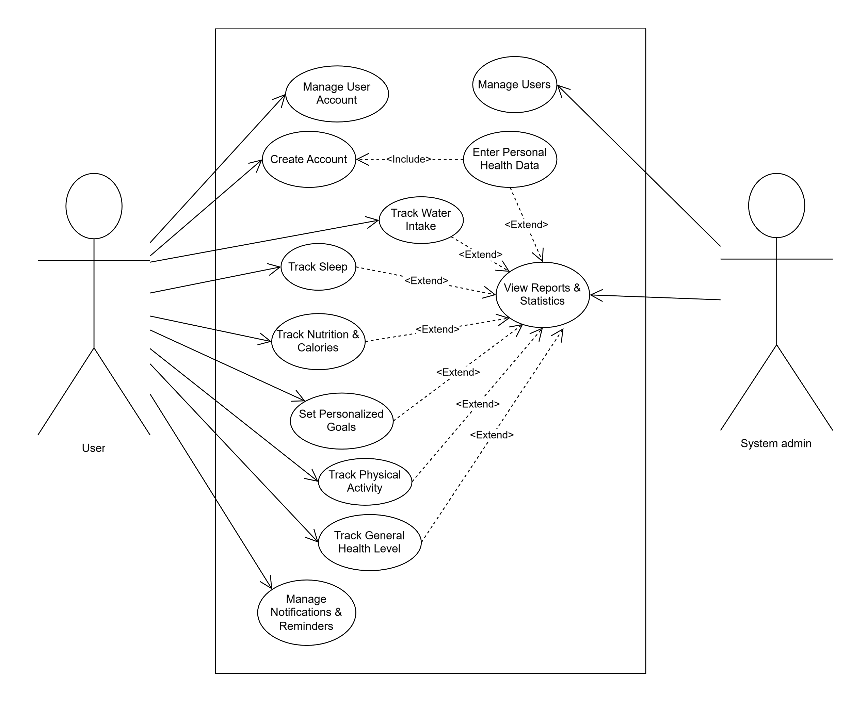
1.2.4.3. Use case diagram:

1.3. Functional requirements

FR ID | Requirement Name | Academic Specification
FR-01 | User Account Creation | The system shall allow users to create a personal account.
FR-02 | User Account Deletion | The system shall allow users to delete their personal account.
FR-03 | User Account Update | The system shall allow users to update their personal account information.
FR-04 | Personal Health Data Entry | The system shall require users to enter personal health data (height, weight, age, gender, physical activity level) through a questionnaire as a prerequisite for completing account creation.
FR-05 | Lifestyle Score Calculation | The system shall calculate a lifestyle score based on the entered questionnaire data and inform the user of their health needs.
FR-06 | Physical Activity Tracking | The system shall provide functionality to track physical activity and support users in improving it.
FR-07 | Physical Activity Goal Setting | The system shall allow users to activate and define a physical activity goal.
FR-08 | Activity Method Selection | The system shall allow users to select their preferred method for achieving the physical activity goal (e.g., gym, running, home workouts).
FR-09 | Step Counter Activation | The system shall allow users to activate a step counter to record daily steps.
FR-10 | Daily Step Target Calculation | The system shall calculate the required daily number of steps to achieve the defined physical activity goal.
FR-11 | Exercise Logging | The system shall allow users to log exercises performed during the day.
FR-12 | Running Activity Analysis | When running is selected, the system shall calculate distance, speed, and duration.
FR-13 | Burned Calories Calculation | The system shall calculate burned calories using the MET (Metabolic Equivalent of Task) rate.
FR-14 | Daily Calorie Adjustment | The system shall adjust the recommended daily caloric intake based on physical activity level and defined goals.
FR-15 | Weekly Activity Hours Definition | The system shall allow users to define a minimum number of weekly physical activity hours required to achieve their goal.
FR-16 | Physical Activity Reminders | The system shall allow users to configure the number and timing of physical activity reminders.
FR-17 | Weight Status Classification | The system shall classify the user’s weight status (underweight, normal, overweight, obese) based on height, weight, age, and gender.
FR-18 | Dietary Goal Definition | The system shall allow users to define their dietary goal (weight loss, weight gain, maintenance, muscle building).
FR-19 | Daily Calorie Requirement Calculation | The system shall calculate the daily caloric intake required to achieve the defined dietary goal.
FR-20 | Meal Logging | The system shall allow users to log meals and assign caloric values to each meal.
FR-21 | Food Database Support | The system shall provide a food database to assist in calculating meal calories.
FR-22 | Daily Consumed Calories Calculation | The system shall calculate the total daily consumed calories based on logged meals.
FR-23 | Calorie Intake Monitoring | The system shall monitor user compliance with assigned daily calories and notify the user in case of excess or deficiency.
FR-24 | Weight Update | The system shall allow users to update their weight and recalculate related health metrics accordingly.
FR-25 | Daily Water Requirement Calculation | The system shall calculate the required daily water intake based on user weight and gender.
FR-26 | Water Intake Adjustment | The system shall adjust the daily water requirement based on physical activity performed on the same day.
FR-27 | Water Tracking Activation | When water tracking is activated, the system shall display periodic reminders to drink water.
FR-28 | Water Intake Logging | The system shall allow users to log consumed water and track progress toward the daily goal.
FR-29 | Water Intake Motivation | The system shall award motivational points to encourage users to meet their daily water intake goal.
FR-30 | Sleep Improvement Activation | The system shall allow users to activate sleep improvement functionality.
FR-31 | Sleep Data Entry | The system shall allow users to define their typical sleep duration and identify sleep patterns (deep, moderate, light, interrupted).
FR-32 | Sleep Duration Calculation | The system shall calculate required sleep duration and recommend appropriate sleep and wake-up times.
FR-33 | Sleep Schedule Management | The system shall allow users to define and update sleep and wake-up times.
FR-34 | Reward Points System | The system shall award points for each health component and calculate an overall health reward score.
FR-35 | Penalty Points Deduction | The system shall deduct points when the user violates defined health goals.
FR-36 | Health Reports Generation | The system shall generate periodic comprehensive reports reflecting the user’s overall health compliance.
FR-37 | Personal Goal Creation | The system shall allow users to create personalized health goals based on individual needs.
FR-38 | Goal Duration and Reminder Configuration | The system shall allow users to define goal tracking duration and configure reminder times.
FR-39 | Goal Progress Tracking | The system shall track user compliance and progress toward achieving defined personal goals.

1.4. Non-functional requirements

NFR ID | Category | Academic Specification
NFR-01 | Performance | The system shall respond to user requests within a maximum of 2 seconds under normal operating conditions.
NFR-02 | Performance | The system shall support concurrent access by multiple users without significant degradation in response time.
NFR-03 | Security | The system shall encrypt sensitive user data during storage and transmission.
NFR-04 | Security | The system shall store user passwords using secure hashing algorithms.
NFR-05 | Privacy | The system shall ensure the confidentiality of personal and health-related user data and prevent unauthorized access.
NFR-06 | Reliability | The system shall maintain an operational availability of at least 99%.
NFR-07 | Reliability | The system shall recover gracefully from system failures without loss of critical user data.
NFR-08 | Usability | The system shall provide a clear, consistent, and user-friendly interface suitable for non-technical users.
NFR-09 | Usability | The system shall minimize user interaction steps required to perform common tasks.
NFR-10 | Scalability | The system shall support future growth in the number of users and stored data without major architectural changes.
NFR-11 | Maintainability | The system shall be designed using a modular architecture to facilitate maintenance and future enhancements.
NFR-12 | Compatibility | The system shall operate on both Android and iOS platforms.
NFR-13 | Interoperability | The system shall be capable of integrating with external health services such as Pedometer and GPS.
NFR-14 | Data Integrity | The system shall ensure the accuracy and consistency of stored health data.
NFR-15 | Availability | The system shall be accessible to users at any time, except during scheduled maintenance periods.

1.5. Constraints Section

1.5.1. Introduction
The system is subject to several constraints that must be considered during development and deployment. These constraints represent limitations related to technology, resources, time, and external dependencies, and they directly influence the design and implementation of the VitaMate system.
Constraint ID | Type | Description
C-01 | Technical | The system must operate on Android and iOS platforms.
C-02 | Technical | Integration depends on the availability and reliability of external health APIs (Google Fit and Apple Health).
C-03 | Security | The system must adhere to data privacy standards due to the sensitivity of health information.
C-04 | Connectivity | An active internet connection is required for synchronization and report generation.
C-05 | Resource | System performance must consider limited device resources such as memory and battery usage.
C-06 | Development | The development schedule is constrained by the academic semester timeframe.
C-07 | Legal | The system shall comply with regulations related to data protection (e.g., GDPR-like standards if applicable).

Analysis diagram

2.1. introduction
The Analysis Diagram represents the conceptual structure of the VitaMate system during the requirements analysis phase. It identifies the main classes, their responsibilities, and their relationships, without considering implementation details. The purpose of this diagram is to model the problem domain and ensure a clear understanding of how system components interact to fulfill the functional requirements. By visualizing associations, aggregations, and dependencies, the diagram provides a high-level abstraction that supports accurate system design and forms a foundation for subsequent architectural and class diagrams.

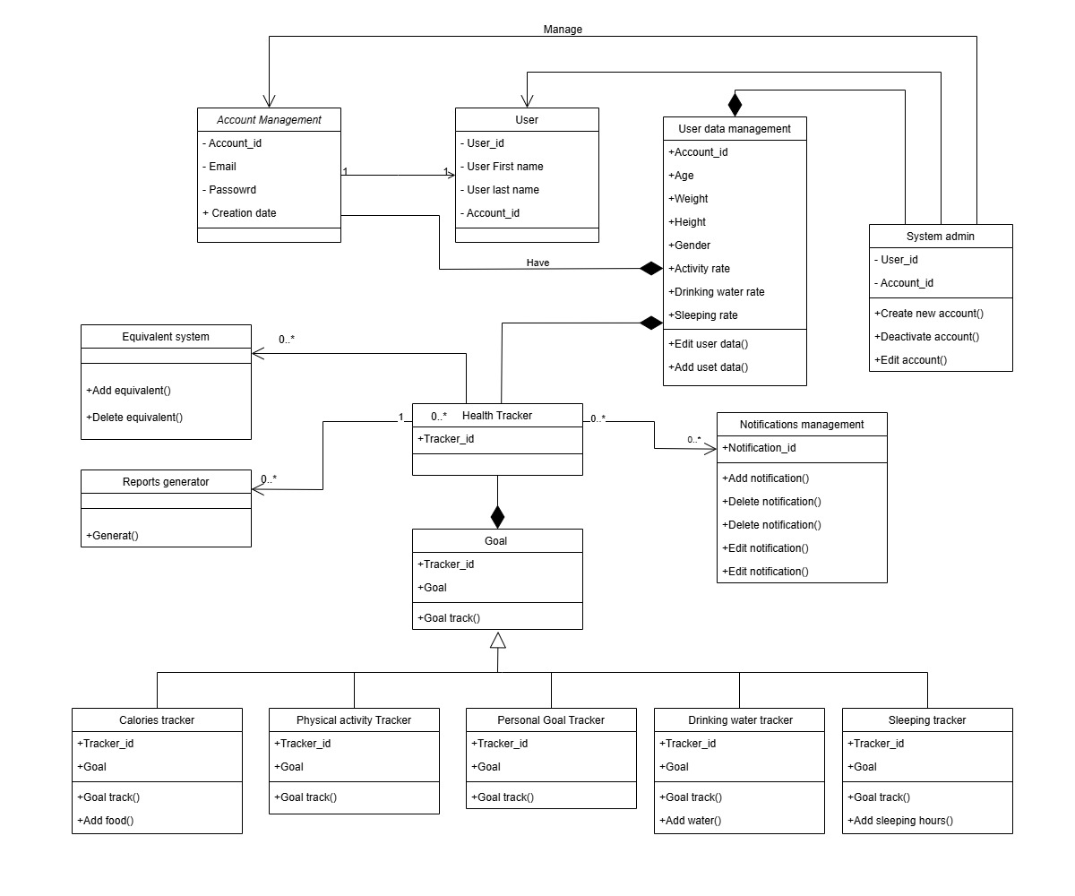
2.2. Analysis class diagram

Initial Test Cases

Introduction
The Initial Test Cases provide an early verification approach to ensure that the core functional requirements of the VitaMate system are fulfilled. These test cases outline expected inputs, execution steps, and corresponding outputs for essential scenarios such as authentication, data tracking, and goal management. By defining these tests at an early stage, the project ensures traceability between requirements and validation activities, helping identify potential issues before implementation and guiding quality assurance throughout development.

Test cases

Test Case ID | Title | Pre-Conditions | Steps | Expected Result
TC-01 | User Registration with Valid Data | User is not registered; registration page is accessible. | 1) Open registration page.  2) Enter valid email, password, and confirm password.  3) Submit form. | A new user account is created and a success message is displayed.
TC-02 | User Registration with Existing Email | An account already exists with the same email. | 1) Open registration page.  2) Enter existing email and valid password.  3) Submit form. | System rejects registration and displays an error message indicating that the email is already in use.
TC-03 | Successful Login | User account exists with correct credentials. | 1) Open login page.  2) Enter correct email and password.  3) Click “Login”. | User is authenticated and redirected to the main dashboard.
TC-04 | Add Meal and Update Daily Calories | User is logged in. | 1) Navigate to “Nutrition”. 2) Add a new meal and select food items.  3) Save meal. | The meal is stored and daily consumed calories are updated correctly.
TC-05 | Log Water Intake and Update Progress | User is logged in and has a daily water goal. | 1) Navigate to “Water Tracking”.  2) Enter 250 ml of water intake.  3) Save. | A new water record is stored and progress toward the daily water goal is updated.
TC-06 | Create Physical Activity Record | User is logged in. | 1) Navigate to “Activity Tracking”.  2) Add a new activity (e.g., running 30 minutes).  3) Save. | A new activity record is created and burned calories are calculated and stored.
TC-07 | Log Sleep Session | User is logged in. | 1) Navigate to “Sleep Tracking”.  2) Enter sleep start and end times.  3) Save. | A new sleep record is stored and sleep duration is calculated correctly.
TC-08 | Create Personal Goal | User is logged in. | 1) Navigate to “Goals”.  2) Create a new goal (e.g., 2000 ml water/day). 3) Define duration and save. | A new goal is stored with correct target value and duration.
TC-09 | Reward Points for Goal Completion | User has an active daily goal and meets the target. | 1) Perform actions to reach the goal (e.g., reach water intake target). 2) Trigger daily evaluation. | System marks the goal as achieved and adds points to the user’s reward account.
TC-10 | Generate Weekly Health Report | User has activity, nutrition, water, and sleep data for at least 7 days. | 1) Navigate to “Reports”. 2) Request weekly report. | System generates a weekly report summarizing health metrics and adherence.

RTM

5.1. Introduction
The Requirements Traceability Matrix (RTM) is used to link system requirements with their corresponding test cases. It ensures that every requirement is verified, prevents missing functionality, and supports quality assurance by providing clear traceability throughout the development process.

Requirement ID | Description | Type | Priority | Test Case ID | Verification Method | Status
FR-01 | The system shall allow users to create a new account. | Functional | High | TC-01 | Test | Pending
FR-02 | The system shall allow users to delete their account. | Functional | Medium | TC-02 | Test | Pending
FR-03 | The system shall allow users to update account information. | Functional | Medium | TC-03 | Test | Pending
FR-04 | The system shall allow users to enter personal health data. | Functional | High | TC-01, TC-03 | Inspection / Test | Pending
FR-05 | The system shall calculate a lifestyle score. | Functional | High | TC-10 | Analysis / Test | Pending
FR-06 | The system shall track physical activity. | Functional | High | TC-06 | Test | Pending
FR-07 | The system shall allow users to set activity goals. | Functional | Medium | TC-08 | Test | Pending
FR-08 | The system shall allow users to select a preferred activity method. | Functional | Low | TC-06 | Test | Pending
FR-09 | The system shall support step tracking. | Functional | Medium | TC-06 | Test | Pending
FR-10 | The system shall calculate required daily steps. | Functional | Medium | TC-06 | Analysis / Test | Pending
FR-11 | The system shall allow users to log exercises. | Functional | Medium | TC-06 | Test | Pending
FR-12 | The system shall analyze running activity. | Functional | Medium | TC-06 | Test | Pending
FR-13 | The system shall calculate burned calories. | Functional | High | TC-06 | Analysis / Test | Pending
FR-14 | The system shall adjust daily caloric intake. | Functional | High | TC-04 | Analysis / Test | Pending
FR-15 | The system shall define weekly activity hours. | Functional | Medium | TC-06 | Test | Pending
FR-16 | The system shall send physical activity reminders. | Functional | Medium | TC-09 | Demonstration / Test | Pending
FR-17 | The system shall classify user weight status. | Functional | High | TC-04 | Analysis / Test | Pending
FR-18 | The system shall allow users to set dietary goals. | Functional | High | TC-04, TC-08 | Test | Pending
FR-19 | The system shall calculate daily calorie requirements. | Functional | High | TC-04 | Analysis | Pending
FR-20 | The system shall allow users to log meals. | Functional | High | TC-04 | Test | Pending
FR-21 | The system shall provide a food database. | Functional | Medium | TC-04 | Inspection / Test | Pending
FR-22 | The system shall calculate daily consumed calories. | Functional | High | TC-04 | Analysis | Pending
FR-23 | The system shall monitor caloric intake. | Functional | High | TC-04 | Demonstration / Test | Pending
FR-24 | The system shall allow users to update weight. | Functional | Medium | TC-04 | Test | Pending
FR-25 | The system shall calculate water intake needs. | Functional | High | TC-05 | Analysis | Pending
FR-26 | The system shall adjust water needs based on activity. | Functional | Medium | TC-05 | Analysis | Pending
FR-27 | The system shall send water reminders. | Functional | Medium | TC-05 | Demonstration / Test | Pending
FR-28 | The system shall track water intake. | Functional | High | TC-05 | Test | Pending
FR-29 | The system shall award motivational water points. | Functional | Low | TC-09 | Test | Pending
FR-30 | The system shall allow users to activate sleep improvement. | Functional | Medium | TC-07 | Test | Pending
FR-31 | The system shall allow users to enter sleep data. | Functional | High | TC-07 | Test | Pending
FR-32 | The system shall calculate sleep duration. | Functional | High | TC-07 | Analysis / Test | Pending
FR-33 | The system shall allow sleep schedule adjustments. | Functional | Medium | TC-07 | Test | Pending
FR-34 | The system shall award reward points. | Functional | Medium | TC-09 | Test | Pending
FR-35 | The system shall deduct penalty points. | Functional | Medium | TC-09 | Test | Pending
FR-36 | The system shall generate health reports. | Functional | High | TC-10 | Test | Pending
FR-37 | The system shall allow users to create personal goals. | Functional | High | TC-08 | Test | Pending
FR-38 | The system shall configure goal duration and reminders. | Functional | Medium | TC-08, TC-09 | Test | Pending
FR-39 | The system shall track goal progress. | Functional | High | TC-09 | Test | Pending

Chapter 5

System Design

Chapter introduction
The development of the VitaMate system was carried out using the Agile Scrum methodology, which enabled an iterative and incremental approach to system design and implementation. Instead of constructing the entire system in a single phase, the development process was divided into multiple sprints, each delivering a functional software increment based on prioritized user stories. This chapter presents the system design and illustrates how the architectural models, database structures, and core modules evolved throughout the sprint cycle. The sprint planning, execution, and review ensured continuous refinement of the design and supported adaptability to changing requirements, resulting in a scalable, maintainable, and user-centered system.

2. Sprint Planning & Backlog
The development schedule of the VitaMate system was structured according to the Agile Scrum methodology, where the project lifecycle was divided into six major sprints. These sprints were planned and scheduled as illustrated in the Gantt chart, allowing for incremental delivery and continuous refinement. The Product Backlog served as the central repository of all user requirements and features, from which sprint tasks were selected based on priority, feasibility, and dependencies.

2.1. Sprint 0 – Requirements Analysis and Planning
The initial sprint focused on establishing the foundational understanding of the system. Key activities included requirements elicitation, problem domain analysis, creation of the SRS document, and initial design modeling. During this sprint, the project scope, goals, and architectural direction were defined, and the overall sprint plan was formulated.

2.2. Sprint 1 – Core System Setup and User Management
This sprint concentrated on building the fundamental structure of the system. Major deliverables included the initial UI design, project architecture setup, database creation, and implementation of user authentication and profile management. Basic tracking functionality and initial API configuration were also introduced.

2.3. Sprint 2 – Daily and Health Tracking Features
Sprint 2 extended the system with essential health monitoring functions, including sleep tracking, water intake logging, calorie tracking, notifications, and activity steps tracking. The dashboard and recommendation features were developed to support daily habit monitoring.

2.4. Sprint 3 – Activity Tracking and Sensor-Based Features
This sprint focused on advanced activity tracking supported by GPS and sensor data. Features such as workout tracking, calories burned estimation, and enhanced statistical dashboards were delivered in this phase.

2.5. Sprint 4 – Personal Goals and Insights
Sprint 4 introduced goal-oriented features designed to support user motivation and behavior change. Custom goals, goal reminders, integrated statistics, and personalized dashboards were implemented to enhance user engagement and progress monitoring.

2.6. Sprint 5 – Finalization, Testing, and Delivery
The final sprint aimed at stabilizing and optimizing the system. Comprehensive testing, validation against requirements, bug fixing, documentation, and preparation for project delivery were completed. The sprint ensured that the final product aligned with stakeholder expectations.

Backlog Prioritization and Refinement
The Product Backlog was continuously reviewed and updated through sprint reviews and feedback loops. Items were prioritized based on user value, technical effort, and dependency mapping. Higher priority features—such as authentication, daily tracking, and activity logging—were scheduled earlier, while advanced features like goal integration and reporting were planned in later sprints.

Outcome of Sprint Planning
This structured sprint allocation allowed for:
- controlled incremental development
- timely delivery of functional increments
- early risk identification
- frequent adaptation to change
- improved alignment with project objectives

VitaMate Product Backlog

Sprint 0 – Requirements & Planning
Goal: Define system scope and prepare for development.
ID | User Story | Priority
PB-01 | As a stakeholder, I want to define the system scope so that project objectives are clearly established. | High
PB-02 | As a developer, I want to collect user requirements so that the SRS document can be created. | High
PB-03 | As a system analyst, I want to model use cases so that system behavior is understood. | High
PB-04 | As a designer, I want to propose the initial system architecture so that design can begin. | Medium
PB-05 | As a team, I want to plan sprints so that the work is organized and scheduled. | High

2.9.2. Sprint 1 – Core System & User Management
Goal: Build base structure and authentication.
ID | User Story | Priority
PB-06 | As a user, I want to create an account so that I can access the system. | High
PB-07 | As a user, I want to log in securely so that my data remains protected. | High
PB-08 | As a user, I want to update my profile so that my personal data is accurate. | Medium
PB-09 | As a system, I want a database structure so that persistent storage is supported. | High
PB-10 | As a user, I want a home interface so that I can navigate the system easily. | High
PB-11 | As a user, I want basic tracking initialization so that I can start logging data. | Medium

2.9.3. Sprint 2 – Daily & Health Tracking
Goal: Core lifestyle tracking features.
ID | User Story | Priority
PB-12 | As a user, I want to track my sleep duration so that I can improve my sleep cycle. | High
PB-13 | As a user, I want to log my daily water intake so that I can reach hydration targets. | High
PB-14 | As a user, I want to track my calories so that I can monitor my nutrition. | High
PB-15 | As a user, I want notification reminders so that I do not miss daily targets. | Medium
PB-16 | As a user, I want to track steps so that I can monitor my activity. | High
PB-17 | As a user, I want initial statistics visualization so that I can understand my progress. | Medium

2.9.4. Sprint 3 – Activity Tracking & Sensor-Based Features
Goal: Physical activity tracking and advanced sensing.
ID | User Story | Priority
PB-18 | As a user, I want GPS run tracking so that I can measure distance and route. | High
PB-19 | As a user, I want workout logging so that I can document exercise sessions. | High
PB-20 | As a user, I want calories burned estimation so that I can measure workout intensity. | High
PB-21 | As a system, I want sensor integration so that activity tracking is automated. | Medium
PB-22 | As a user, I want dashboard updates so that I can see real activity insights. | Medium

2.9.5. Sprint 4 – Goals & Motivation
Goal: Personal goals, reward system, and insights.
ID | User Story | Priority
PB-23 | As a user, I want to set personal goals so that I can improve my lifestyle. | High
PB-24 | As a user, I want goal reminders so that I stay motivated. | Medium
PB-25 | As a user, I want reward points so that I feel encouraged to meet targets. | High
PB-26 | As a user, I want goal statistics so that I can measure my achievements. | Medium
PB-27 | As a user, I want a personalized dashboard so that insights are tailored to my behavior. | Medium

2.9.6. Sprint 5 – Testing, Refinement & Delivery
Goal: Finalization and deployment.
ID | User Story | Priority
PB-28 | As a tester, I want to verify system functionality so that requirements are met. | High
PB-29 | As a developer, I want to fix defects so that the system becomes stable. | High
PB-30 | As a team, I want to document the system so that delivery is complete. | High
PB-31 | As a stakeholder, I want a final demo so that delivery can be evaluated. | High

Database Design

3.1. Introduction

The Database Design section provides the logical representation of the data model used in VitaMate. It explains the Entity–Relationship Diagram (ERD), identifies key entities and their relationships, and presents how user and health-related data are structured, stored, and accessed. The design ensures data integrity, consistency, and efficient retrieval, forming the basis for the relational schema and supporting system requirements for tracking, analysis, and reporting.

3.2. The ERD (Entity–Relationship Diagram)

3.2.1. ERD Introduction

The Entity–Relationship Diagram (ERD) illustrates the logical data model of the VitaMate system. It defines the main entities, their attributes, and the relationships between them, serving as the blueprint for database design. Through this diagram, data dependencies are clarified and redundancy is minimized, ensuring consistency, integrity, and efficient storage of user and health-related information. The ERD supports translation of system requirements into relational tables and enforces constraints that maintain data quality throughout the system lifecycle.

3.2.2.ERD diagram schema

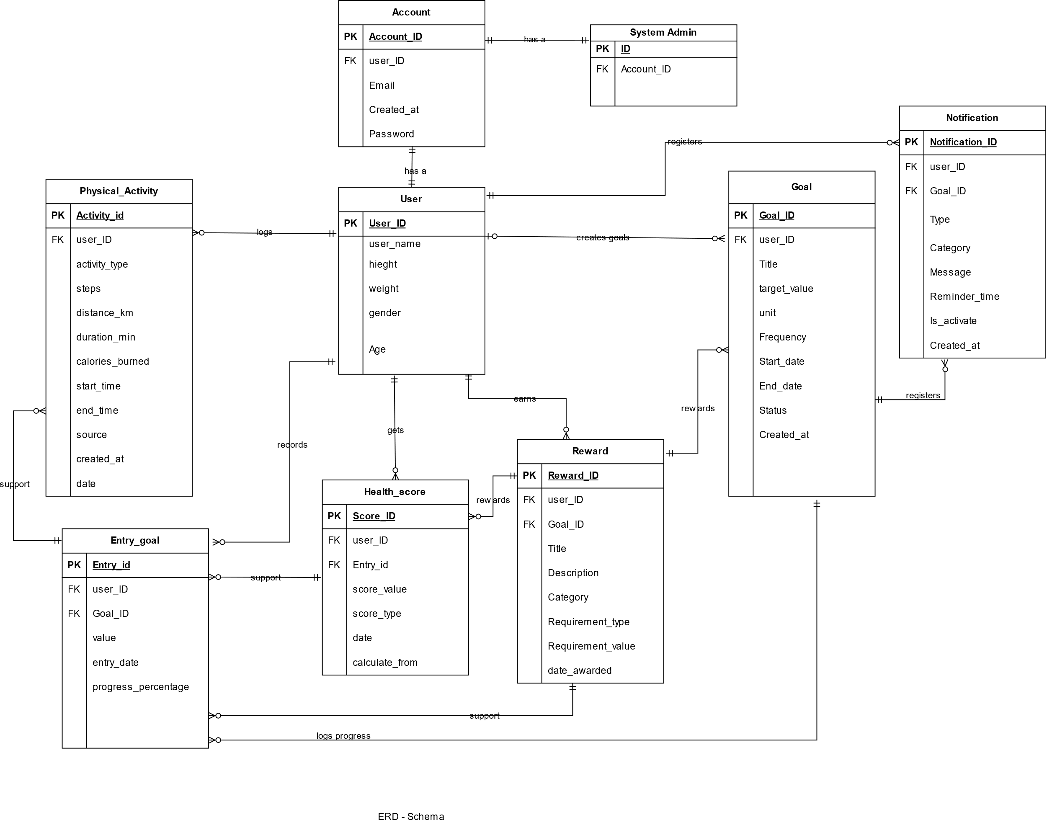

Component Diagram

4.1. Introduction
The Component Diagram illustrates the modular structure of the VitaMate system by decomposing it into independent and functional components. This section describes how each component contributes to system behavior, clarifies communication interfaces, and highlights the separation of concerns between modules such as authentication, tracking, reporting, and goal management. The diagram supports clear organization of system responsibilities and facilitates parallel development and maintenance.

Component diagram
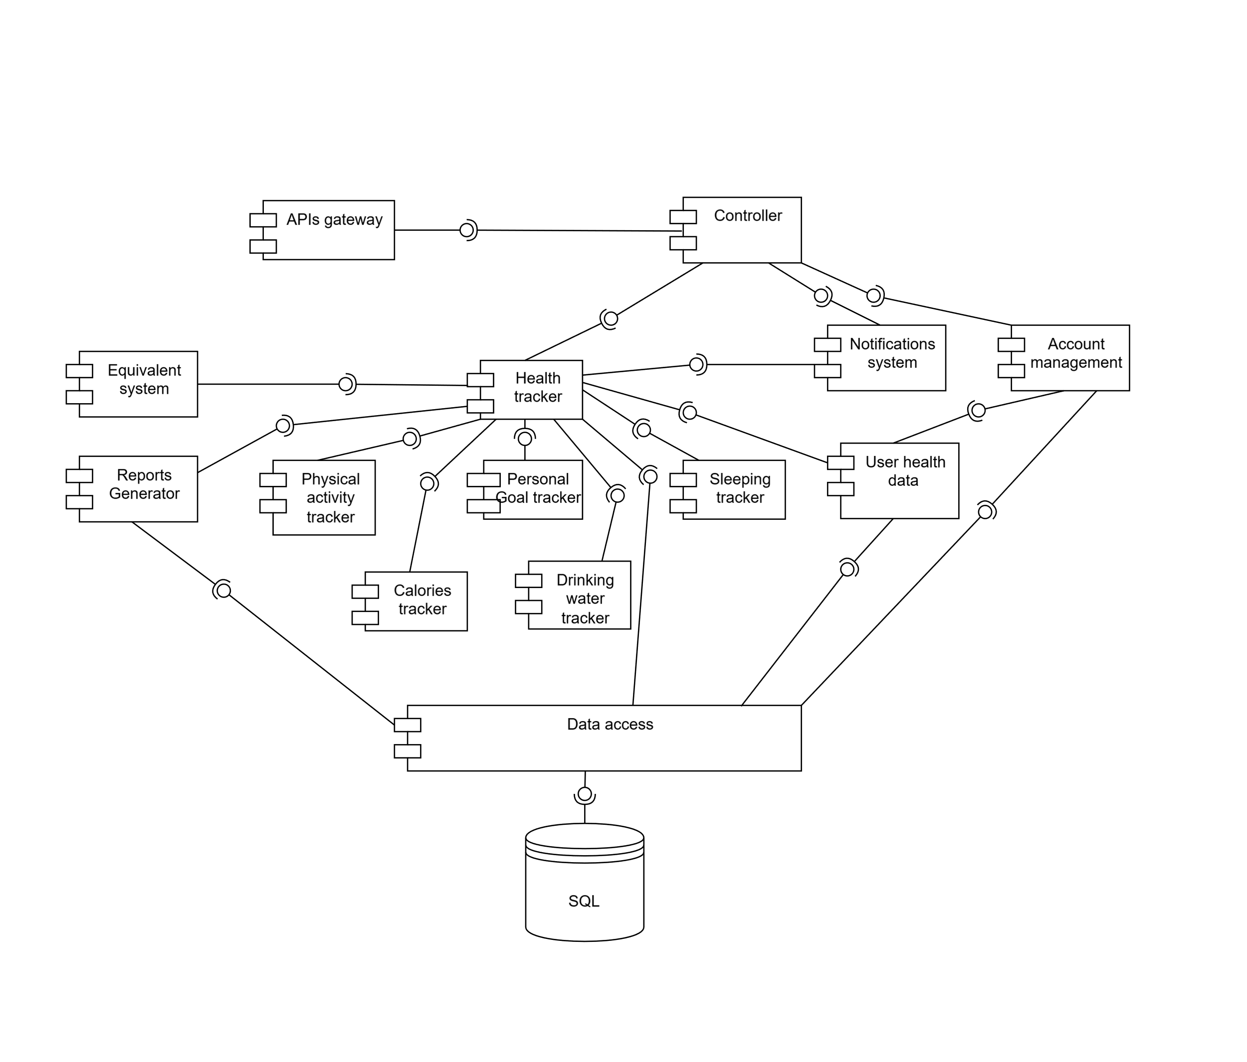

Architecture Design

5.1. Introduction
The Architecture Design section presents the high-level structure of the VitaMate system, illustrating how major components interact to achieve the required functionality. It defines the client–server architecture, identifies the system layers, and explains the flow of data between the mobile application, backend services, and database. This architectural model ensures scalability, maintainability, and efficient integration with external APIs, providing a solid foundation for subsequent detailed design and implementation.

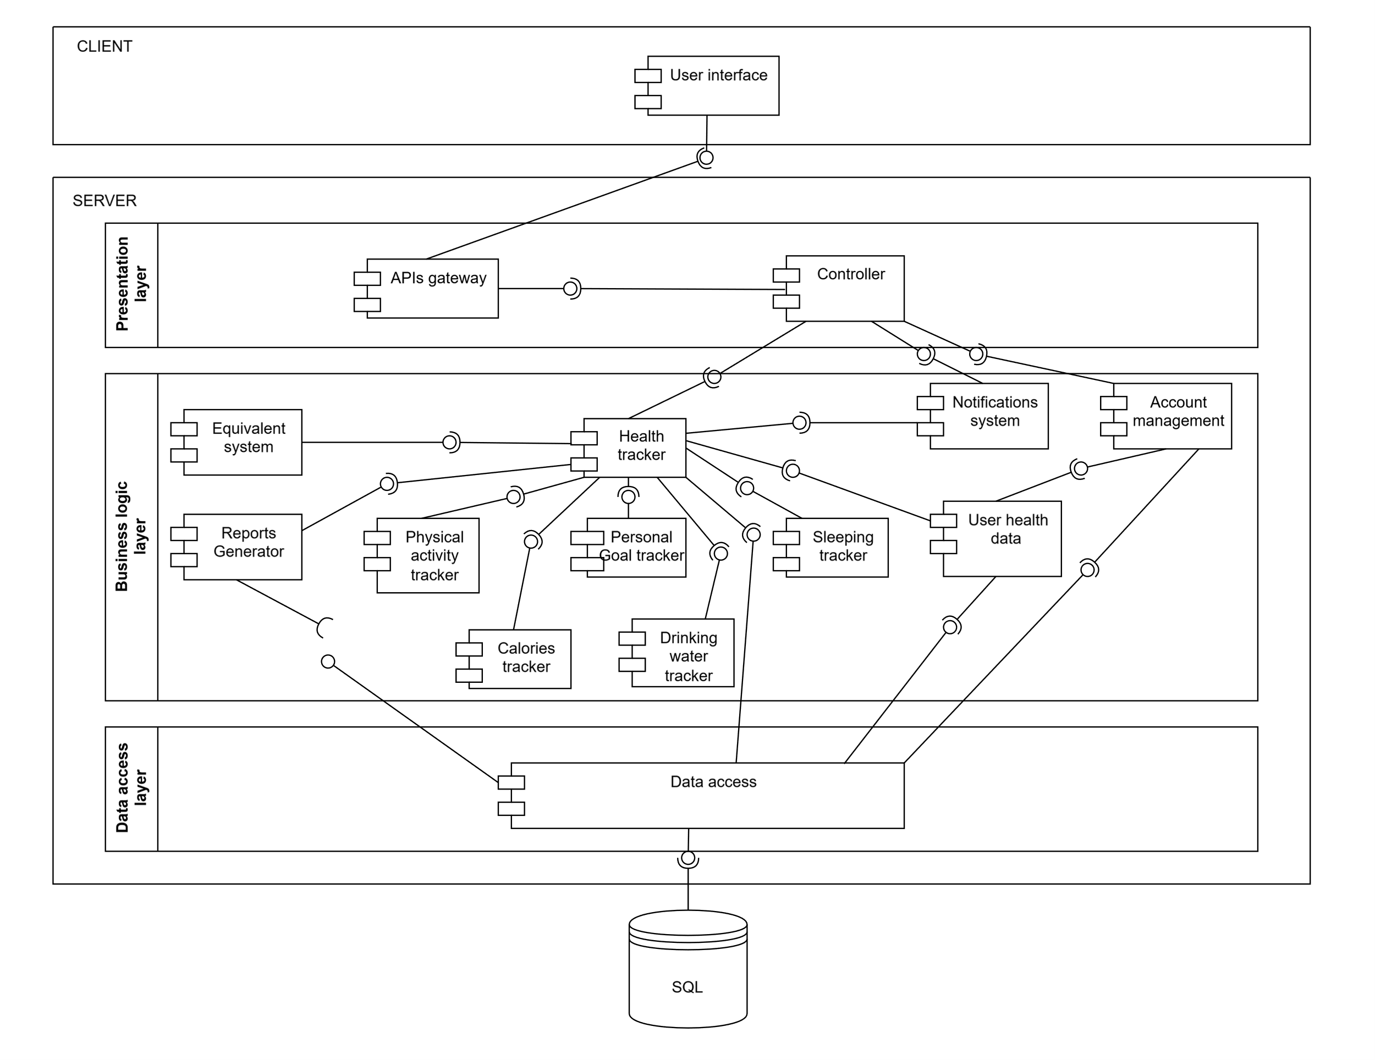
Architecture diagram

5.3. Justification for Using the Component-Based Architecture
The component-based architecture was selected for the VitaMate system due to its ability to support modularity, scalability, and maintainability. By decomposing the system into independent components—such as authentication, tracking modules, goals and rewards, reporting, and external integration—the architecture enables clear separation of responsibilities and reduces interdependencies.
This structure allows individual components to be developed, tested, and refined in parallel, which aligns effectively with the iterative nature of Agile Scrum. Furthermore, updates or enhancements can be introduced with minimal impact on other modules, ensuring adaptability to evolving requirements.
The architecture also improves reliability and integration by enabling controlled communication through well-defined interfaces between the mobile application, backend services, and database. This not only enhances reusability and fault isolation but also supports future expansion, such as adding new tracking features or integrating external

5.4. Detailed Behavioral Diagrams
This section presents the detailed behavioral diagrams for the core functional modules of the VitaMate system, namely water intake tracking, physical activity tracking, sleep tracking, nutrition and calorie management, and personal goal management.
Each module is documented using a sequence diagram and a corresponding activity diagram to describe the interaction between the user interface, backend services, database, and the point-based evaluation system.
These diagrams refine the high-level use cases defined in the SRS and clarify the internal processing logic required to fulfill the system’s functional requirements.

5.4.1. Water Intake Tracking Diagrams
The Water Intake Tracking Sequence Diagram illustrates the interaction flow when the user logs a water intake event.
It shows how the mobile UI sends the entered amount to the backend API, how the Water Tracker component validates and stores the record, and how the Point System updates the user’s hydration-related score based on progress toward the daily water target.
The Water Intake Tracking Activity Diagram models the control flow for this process from the user’s perspective.
It describes the main steps of entering the water amount, validating the input, sending the data to the system, storing the record in the database, recalculating the user’s daily progress and score, and finally updating the user interface with the new hydration status.
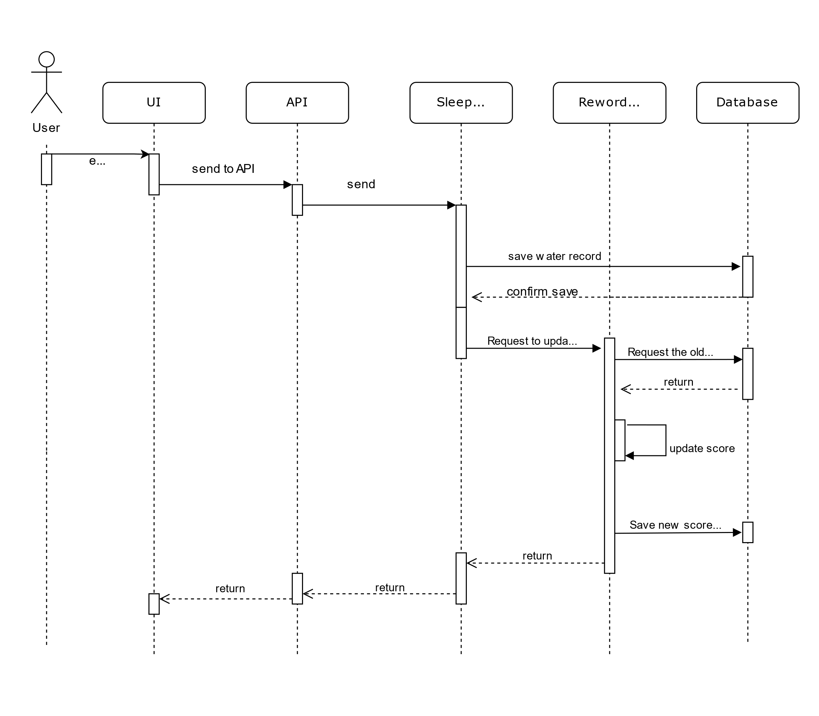
      - Sequence diagram:

5.4.2. Nutrition and Calorie Management Diagrams
The Nutrition Sprint included user stories for meal logging and calorie computation. The diagrams clarify backend interactions with food databases and point-system logic. They were iteratively refined during backlog grooming as dietary goals became better defined.

      - Sequence diagram:
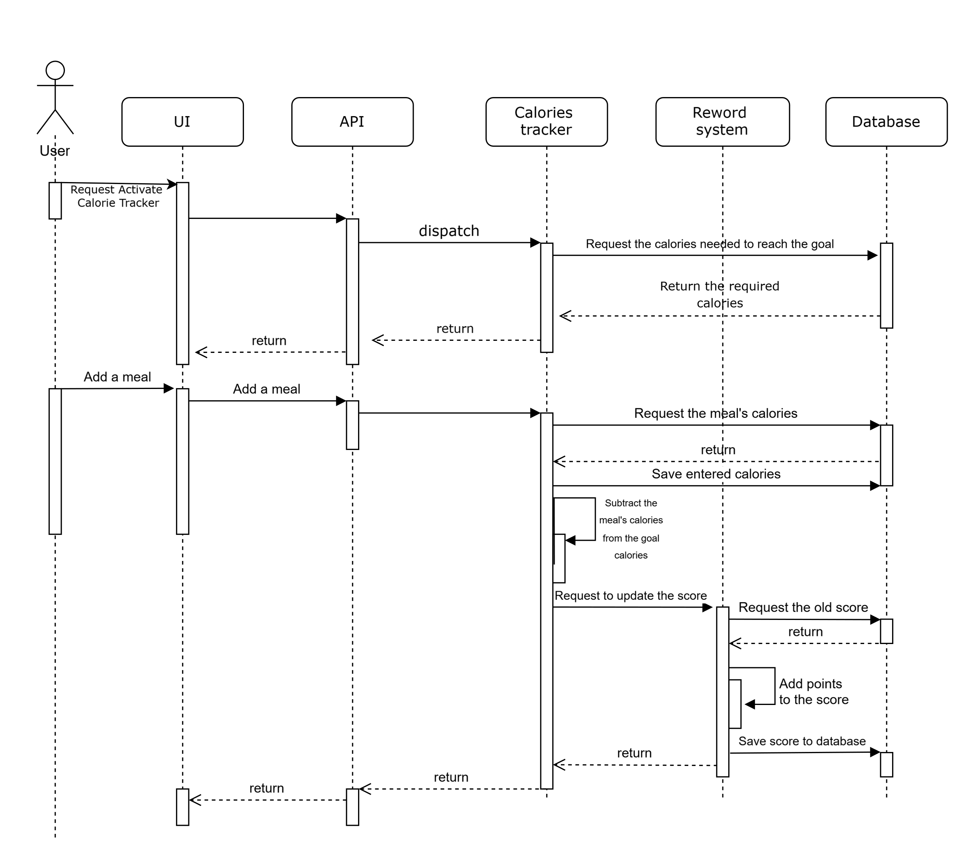

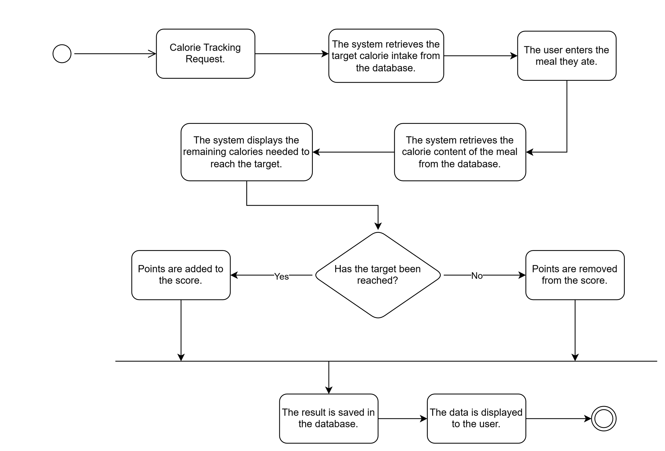
      - Activity diagram:

5.4.3. Physical Activity Tracking Diagrams
The Physical Activity Tracking Sequence Diagram details the message flow for registering a physical activity session such as walking or running.
The diagram captures how the UI forwards activity data (type, duration, distance) to the API, how the Activity Tracker computes burned calories (using MET-based formulas when applicable), persists the session, and triggers the Point System to adjust the lifestyle score according to the user’s activity goals.
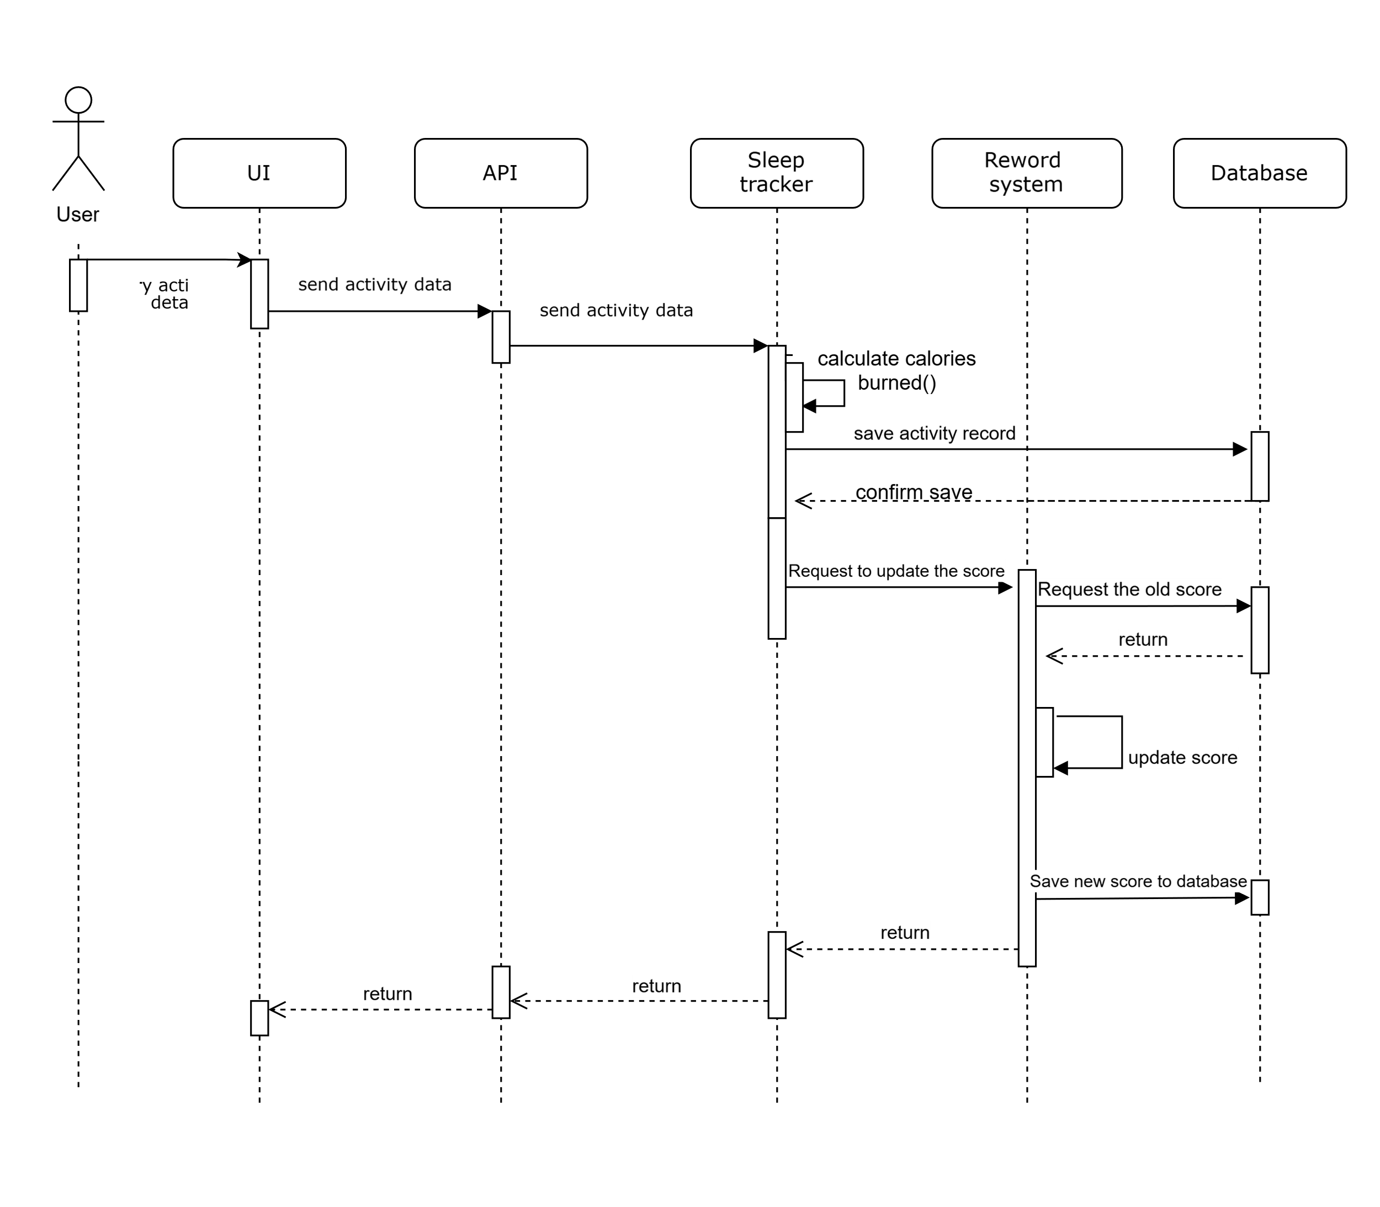
5.4.3.1. Sequence diagram:

Sleep Tracking Diagrams
The Sleep Tracking Sequence Diagram describes how the system processes a logged sleep session.
Starting from the user entering sleep and wake-up times, the diagram shows how the Sleep Tracker calculates the sleep duration, stores the session in the database, and invokes the Point System to compare the actual duration with the predefined sleep target and update the user’s score accordingly.
The Sleep Tracking Activity Diagram provides a detailed view of the control flow for this scenario.
It covers opening the sleep tracking screen, entering time values, validating the input, handling user cancellation or invalid entries, sending valid data to the backend, computing the duration, saving the sleep record, performing the target comparison, and updating the UI with the calculated duration and new score.

Sequence Diagram:
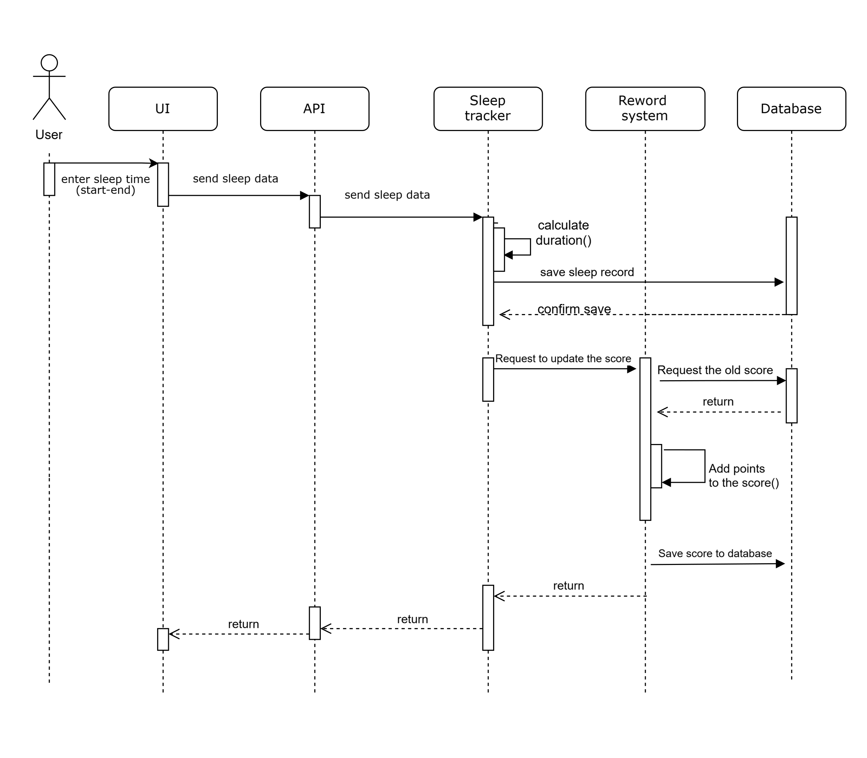
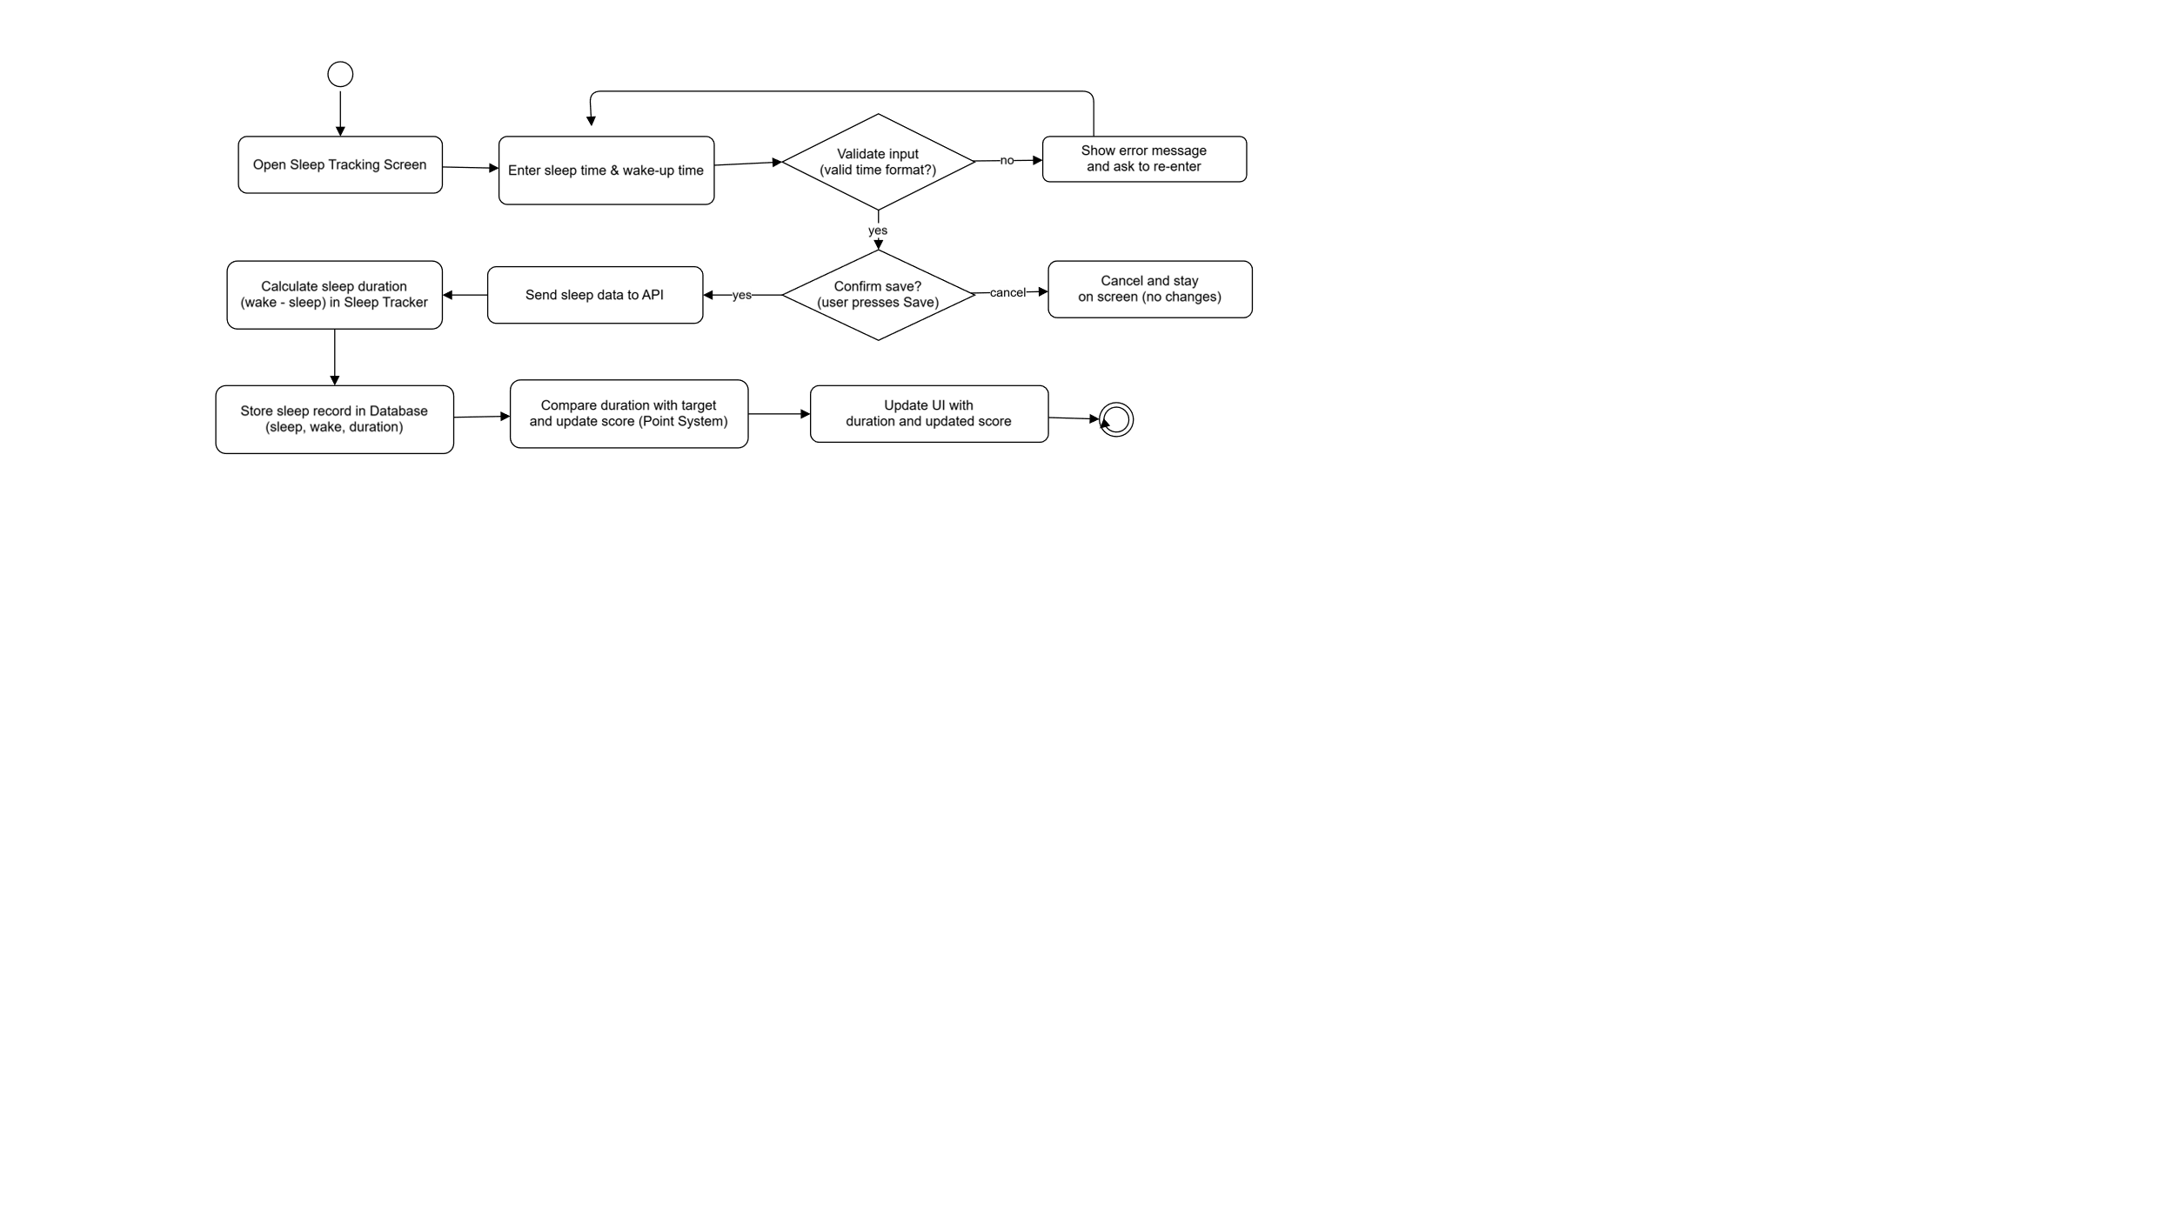
      - Activity diagram:

Personal Goal Management Diagrams
The Personal Goal Management Sequence Diagram focuses on the lifecycle of custom goals defined by the user, such as a water target, sleep duration, or activity time.
The diagram shows how the UI submits a new goal to the backend, how the Goal Management component validates and stores the goal in the database, and how the Point System later uses these stored targets during periodic evaluations of user performance.
The Personal Goal Management Activity Diagram describes the control flow for creating and configuring a personal goal.
It covers entering the goal type and target value, defining the tracking duration and reminder settings, validating the configuration, storing the goal, and confirming successful creation to the user through the interface.
This diagram complements the tracking diagrams by explaining how targets are initially established before being used in daily evaluations.

Sequence Diagram:

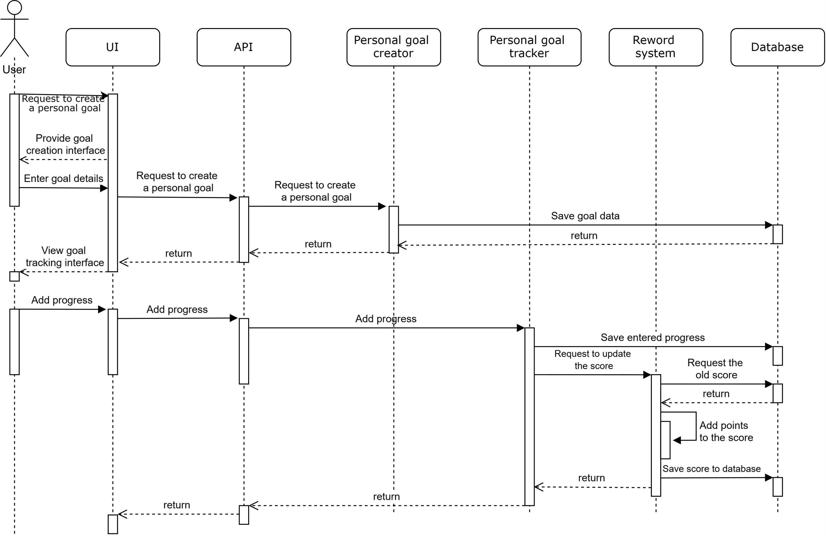

Activity Diagram:

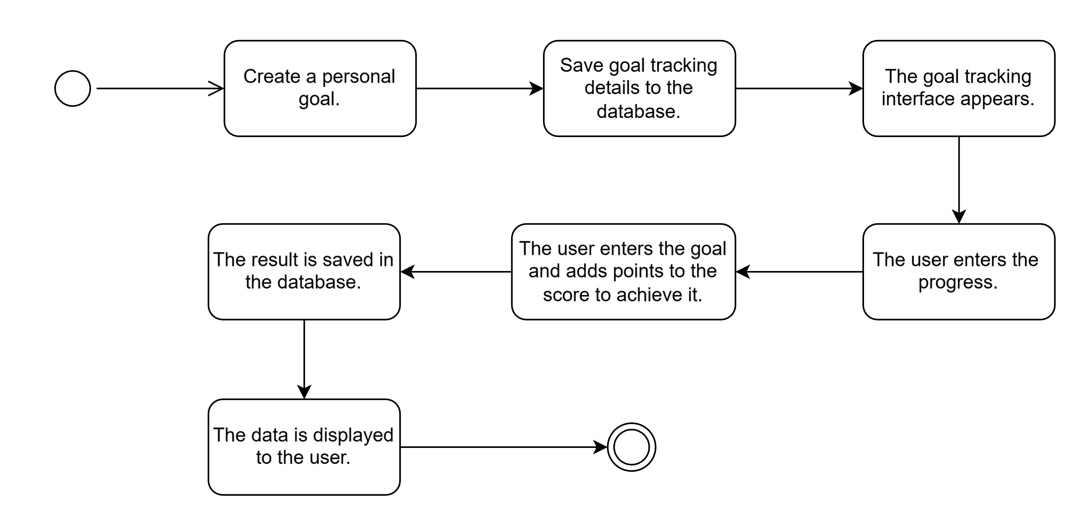

Chapter 6

Implementation

Chapter Introduction
This chapter presents the implementation phase of the VitaMate system, where the system design and requirements are transformed into a working application. It explains the practical use of tools and technologies adopted during development and describes how the frontend and backend components are implemented and integrated. The chapter focuses on the overall system structure and the communication between different components through RESTful APIs.

Tools & Technologies

Introduction
This section presents the main tools and technologies used in the implementation of the VitaMate system. These tools were selected to support efficient development, ensure code quality, and facilitate collaboration between team members. The chosen technologies enable cross-platform mobile development, secure backend services, and effective testing and integration of system components.

Tools and Technologies Description
The tools and technologies used in the implementation of the VitaMate system were selected based on stability, standardization, and suitability for academic and practical software development. Preference was given to widely used frameworks and tools to ensure maintainability, reproducibility, and ease of future extension.
Flutter was used for frontend development to support cross-platform mobile applications using a single codebase. It provides efficient UI rendering and native performance on both Android and iOS platforms.
The backend was developed using Django and Django REST Framework. Django provides a structured framework for backend development, while Django REST Framework supports the creation of RESTful APIs required for communication with the mobile application. This combination enables clear separation of concerns, data validation, and secure request handling.
Git and GitHub were used for version control and collaborative development. They enabled source code management, change tracking, and coordination between development tasks. Visual Studio Code was used as the primary development environment due to its lightweight nature and compatibility with the selected technologies.
Postman was used to test and verify API endpoints during development. It allowed validation of request formats, response data, and authentication mechanisms. Communication between the frontend and backend was implemented using RESTful APIs following standard HTTP methods.

Table: Tools and Technologies Used in VitaMate

Tool / Technology | Category | Purpose
Git | Version Control | Managing source code versions and tracking changes during development.
GitHub | Collaboration Platform | Hosting the code repository and supporting team collaboration and version history.
Flutter | Frontend Framework | Developing a cross-platform mobile application using a single codebase.
Django | Backend Framework | Implementing backend logic and managing server-side operations.
Django REST Framework | API Framework | Building RESTful APIs for communication between frontend and backend.
RESTful API | Communication Standard | Enabling standardized and platform-independent data exchange via HTTP.
Visual Studio Code | Development Environment | Writing, debugging, and managing frontend and backend source code.
Postman | API Testing Tool | Testing, validating, and debugging API endpoints and responses.

Tools and Technologies Justification
The selected tools and technologies form an integrated development environment that supports modularity, scalability, and maintainability. The combination of Flutter and Django REST Framework enables a clear separation between frontend and backend layers while maintaining efficient communication through RESTful APIs. Version control and collaboration tools ensure structured development, while testing and development environments support code reliability and systematic verification. This toolset provides a stable foundation for implementing the system requirements and supporting future enhancements.

Backend structure

Introduction
The VitaMate backend is implemented using Django and Django REST Framework (DRF) following a modular, app-based structure. The backend is responsible for authentication, data persistence, business logic, and RESTful API exposure. System functionality is divided into domain-focused Django apps to support separation of concerns and maintainability.

Project Tree (Backend)
VitaMate/
├── manage.py
├── vitamate_project/
│ ├── settings.py
│ ├── urls.py
│ ├── asgi.py
│ └── wsgi.py
├── users/
│ ├── models.py
│ ├── serializers.py
│ ├── views.py
│ ├── signals.py
│ └── migrations/
├── core/
│ ├── models.py
│ ├── serializers.py
│ ├── views.py
│ └── migrations/
├── gamification/
│ ├── models.py
│ ├── admin.py
│ └── migrations/
└── venv/ (local environment; not part of application logic)

Component | Type | Description
manage.py | File | Main execution entry point used for running the server, applying migrations, and executing Django administrative commands.
vitamate_project/ | Directory | Contains global project configuration and system-level settings.
vitamate_project/settings.py | File | Defines installed apps, database configuration, middleware, authentication settings, and REST framework options.
vitamate_project/urls.py | File | Maps API endpoints to their corresponding views and registers DRF routers.
vitamate_project/asgi.py | File | ASGI configuration file used for asynchronous deployment environments.
vitamate_project/wsgi.py | File | WSGI configuration file used for traditional deployment setups.
users/ | Directory | Handles user registration and user-related data management.
users/models.py | File | Defines the UserProfile model that stores health baselines and personal targets.
users/serializers.py | File | Validates user input data and converts models to and from JSON format.
users/views.py | File | Contains API views for user registration and related operations.
users/signals.py | File | Automatically initializes user-related records such as profiles and score data upon account creation.
users/migrations/ | Directory | Stores database migration files for the users module.
core/ | Directory | Core domain module responsible for health tracking functionality.
core/models.py | File | Defines tracking entities such as meals, water intake, sleep records, activities, steps, medications, and habits.
core/serializers.py | File | Handles validation and serialization of tracking-related data.
core/views.py | File | Exposes RESTful endpoints for logging activities and retrieving aggregated data.
core/migrations/ | Directory | Contains database migrations for core tracking entities.
gamification/ | Directory | Implements the reward and points management subsystem.
gamification/models.py | File | Defines the UserScore model used to store accumulated points and levels.
gamification/migrations/ | Directory | Stores migration files related to the gamification module.
venv/ | Directory | Local Python virtual environment; not part of the system’s logical architecture.

Module Responsibilities (Formal Description)

1) vitamate_project/ (Project configuration layer)
- settings.py: Global configuration (installed apps, database settings, middleware, authentication).
- urls.py: API routing; registers DRF routers and authentication endpoints.
- asgi.py / wsgi.py: Deployment entry points.

2) users/ (Identity and user profile layer)
- views.py: Registration endpoint (RegisterView).
- serializers.py: User registration validation (RegisterSerializer).
- models.py: UserProfile stores user health-related baseline data and targets (e.g., water, calories, activity goal).
- signals.py: Creates default UserProfile and initializes UserScore when a new user is created.
3) core/ (Health tracking domain layer)
Contains most tracking entities and APIs:
- Models: FoodItem, MealLog, WaterLog, Exercise, ActivityLog, StepLog, SleepLog, Medicine, MedicineLog, Habit, HabitLog.
- ViewSets: CRUD endpoints for daily tracking (nutrition, water, activity, sleep, habits).
- DashboardView: Aggregates daily summaries (calories, hydration, steps/distance, points).

4) gamification/ (Reward and points layer)
- models.py: UserScore maintains points and level progression.
- Points are updated from tracking actions (e.g., water logging adds points).

API Routing (Where endpoints are defined)

Routing is defined in: vitamate_project/urls.py
- Authentication:
  - api/auth/register/ → users.views.RegisterView
  - api/auth/login/ → JWT token obtain (SimpleJWT)
  - api/auth/refresh/ → JWT refresh
- Core APIs (router under api/):
  - /api/meals/, /api/water/, /api/medicines/, /api/steps/, /api/activities/, /api/sleep/, /api/habits/
- Aggregation:
  - /api/dashboard/ → core.views.DashboardView

Traceability: Sprints & Requirements → Code Locations
Note: The mapping below reflects what is implemented in the provided backend codebase. Items not found in the backend are marked as not implemented server-side (typically handled in Flutter or pending).

Sprint 1 — Core setup & user management
Backlog items: PB-06, PB-07, PB-08, PB-09, PB-10, PB-11
- Account creation (FR-01)
  - users/views.py → RegisterView
  - users/serializers.py → RegisterSerializer
  - vitamate_project/urls.py → /api/auth/register/
- Login / secure auth
  - vitamate_project/urls.py → /api/auth/login/, /api/auth/refresh/ (JWT)
- Profile baseline creation (FR-04: health baseline entry — partially server-side)
  - users/signals.py → auto-creates UserProfile with defaults on user creation
  - users/models.py → UserProfile fields (height, weight, gender, etc.)
- Initial DB structure
  - users/migrations/, core/migrations/, gamification/migrations/
Not found in backend:
- FR-02 (account deletion endpoint) — not implemented server-side
- FR-03 (profile update endpoint) — no dedicated API found in backend

Sprint 2 — Daily & health tracking
Backlog items: PB-12, PB-13, PB-14, PB-15, PB-16, PB-17
- Sleep tracking (FR-31/FR-32 partial)
  - Model: core/models.py → SleepLog (+ duration_hours property)
  - API: core/views.py → SleepLogViewSet
  - Route: vitamate_project/urls.py → /api/sleep/
- Water intake logging (FR-28)
  - Model: core/models.py → WaterLog
  - API: core/views.py → WaterLogViewSet
  - Points: core/views.py → WaterLogViewSet.perform_create() calls UserScore.add_points(5)
  - Route: /api/water/
- Nutrition & calories (FR-20/FR-21/FR-22 partial)
  - Models: core/models.py → FoodItem, MealLog
  - API: core/views.py → MealLogViewSet
  - Route: /api/meals/
- Steps tracking (FR-09) + distance (FR-12 partial)
  - Model: core/models.py → StepLog (contains steps_count, distance_km)
  - API: core/views.py → StepLogViewSet
  - Route: /api/steps/
- Statistics visualization / dashboard
  - API: core/views.py → DashboardView
  - Route: /api/dashboard/
Not found in backend:
- Notifications/reminders (PB-15, FR-16/FR-27) — no scheduling/notification service in backend code (likely handled client-side)

Sprint 3 — Activity tracking & sensor-based features
Backlog items: PB-18, PB-19, PB-20, PB-21, PB-22
- Workout logging (PB-19 / FR-11 partial)
  - Models: core/models.py → Exercise, ActivityLog
  - API: core/views.py → ActivityLogViewSet
  - Route: /api/activities/
- Calories burned estimation (PB-20 / FR-13)
  - Logic: core/models.py → ActivityLog.calories_burned uses MET formula referencing user weight from UserProfile
- GPS run tracking / sensor integration (PB-18 / PB-21)
  - Backend provides distance_km field in StepLog, but no GPS route/session model is implemented.
  - Sensor/GPS integration appears not implemented server-side (likely collected on mobile and pushed as aggregated values).

Sprint 4 — Goals & motivation
Backlog items: PB-23, PB-24, PB-25, PB-26, PB-27
- User targets / goal-related baselines (FR-07, FR-14, FR-17, FR-18, FR-19, FR-25)
  - users/models.py → UserProfile contains goal/target fields (daily water target, daily calorie target, step goal, etc.) and calculations (e.g., TDEE adjustment).
- Habits tracking (FR-39)
  - Models: core/models.py → Habit, HabitLog
  - APIs: core/views.py → HabitViewSet (+ HabitLogViewSet if used)
  - Route: /api/habits/
- Reward system (FR-34)
  - gamification/models.py → UserScore
  - Initialized in users/signals.py and updated from tracking actions (e.g., water logging)
Not found in backend:
- A dedicated “Goal” entity/model and goal reminders configuration — no Goal model/endpoints found server-side.

Sprint 5 — Testing, refinement & delivery
Backlog items: PB-28, PB-29, PB-30, PB-31
- core/tests.py, users/tests.py, gamification/tests.py exist (test scaffolding).
- No extended automated test suite content was identified beyond basic structure (implementation may be minimal or pending).

API Endpoints Table (Backend – Django REST Framework)
Note: ViewSets registered in the backend router expose standard REST operations:
- Collection: GET /api/<resource>/ (list), POST /api/<resource>/ (create)
- Detail: GET/PUT/PATCH/DELETE /api/<resource>/{id}/

Authentication
Endpoint | Method | Purpose
/api/auth/register/ | POST | Create a new user account.
/api/auth/login/ | POST | Obtain JWT access/refresh tokens.
/api/auth/refresh/ | POST | Refresh JWT access token.

Core System APIs

Module | Endpoint | Methods | Purpose
Dashboard | /api/dashboard/ | GET | Returns aggregated daily summary data (progress overview).
Nutrition | /api/meals/ | GET, POST | List or create meal logs.
Water | /api/water/ | GET, POST | List or create water intake logs.
Medicines | /api/medicines/ | GET, POST | List or create medicines.
Steps | /api/steps/ | GET, POST | List or create step logs (steps/distance).
Activities | /api/activities/ | GET, POST | List or create activity logs (duration, calories, etc.).
Sleep | /api/sleep/ | GET, POST | List or create sleep logs.
Habits | /api/habits/ | GET, POST | List or create habit entries/logs.

Frontend Structure (Flutter)

Introduction
The VitaMate mobile application is implemented using Flutter and organized using a feature-based modular structure. The codebase separates authentication, core infrastructure, and domain features (water, sleep, nutrition, activity, goals, statistics) to improve maintainability and reduce coupling between modules.

Project Tree (Flutter – lib/)
lib/
├── main.dart
├── app.dart
├── auth/
│ ├── data/
│ ├── models/
│ ├── screens/
│ └── state/
├── core/
│ ├── config/
│ ├── network/
│ ├── routing/
│ ├── services/
│ ├── storage/
│ └── theme/
├── features/
│ ├── activity/
│ ├── goals/
│ ├── home/
│ ├── nutrition/
│ ├── sleep/
│ ├── stats/
│ └── water/
└── shared/
├── models/
├── utils/
└── widgets/

Structure Explanation (Table)
Component | Description
main.dart | Application entry point; starts the Flutter app (runApp).
app.dart | Root widget; initializes MaterialApp, theme, and route mapping.
auth/ | Authentication module (login/signup + onboarding flow + auth state).
auth/data/ | Auth API and repository layer (HTTP calls + data access abstraction).
auth/models/ | Auth data models (e.g., token, user, profile).
auth/screens/ | UI screens (login, signup, onboarding wizard).
auth/state/ | Controllers/state management for auth flow.
core/ | App-wide infrastructure used by all features.
core/config/ | Constants/configuration (e.g., base URL and endpoint paths).
core/network/ | HTTP client (Dio), interceptors (JWT attach/refresh), and logging.
core/routing/ | Route names and navigation organization.
core/services/ | Shared services used across modules (if any).
core/storage/ | Local storage utilities (token persistence, preferences).
core/theme/ | UI theme definitions (colors, typography, global styling).
features/ | Domain features grouped by module (water, sleep, nutrition, activity, etc.).
features/<module>/data/ | API layer for the feature endpoints.
features/<module>/models/ | Feature-specific data models.
features/<module>/screens/ | Feature UI screens.
features/<module>/state/ | Feature controllers/state logic.
shared/ | Reusable widgets, utilities, and shared models used by multiple modules.

